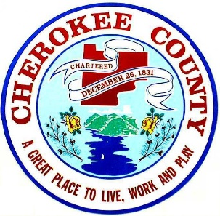
Cherokee County Board of Commissioners
ADDRESS AND STREET NAME APPLICATION
(P) 678-493-6050
addressing@cherokeecountyga.gov

Note: By submitting this request in writing, you certify that you are qualified to make this request and are taking responsibility for any changes made. Signature: ________________________________ Date: _______________

Applicant:
Contact Name: Phone:
Mailing Address:

City: State: Zip:

Email Address:

I am:
Requesting a new address number.
Requesting a new street name of __________________________________________.
Requesting to change my existing address number
Existing Address Number: _________________
Requesting to change my existing street name
Existing Street Name: _________________________________________________
Proposed New Street Name: ___________________________________________
Please indicate reason for request: ____________________

Type of Address:
Residential: _____ Commercial: ______ Other (please specify): __________________________________________

Subdivision Name (if applicable): _______________________________________________________________________________

Land District: _________ Land Lot: ________ Map Number: __________________ Parcel Number: ______________________

Cherokee County Office Use Only Date Received: ______

Date Reviewed by GIS: By:

Date Confirmed by E911: By:

BOC Approval Date: ________________Agenda Item: ______________

Comments:____________________________________________________________________________________________

Instructions:

- Please provide a survey of the site location with your application.
- Applications for multiple street names for new development may be submitted on one application with an attached list of Street Names proposed.
- Applications requesting change to existing street names must be submitted by governing agency and include copy of petition and/or resolution.
- Requests require a 5 business-day notice to research and route through Emergency Services.
  - Note: Final street name approval will require majority vote at regularly scheduled meeting of the Cherokee County Board of Commissioners.
- Thank you for your request, the results of this application will be emailed to the address specified above.

